

PROJECT: OnBookStore
GROUP NO:05 BATCH: T1.2206.E1

A. SYSTEM REQUIREMENTS:
Sr. | Item | Description
1. | Operating system | Windows, IOS
2. | Hardware | CPU Core i5, Ryzen 5
3. | Web Browser | Version in later of: Edge, Chrome
4. | Fonts | Standard font Unicode: Arial, Tahoma, Lucida Console, Times New Roman, etc…
5. | Other requirement | Git, XAMPP 7.3 or later | A working internet connection.
Notes: Do not install IDEs (Integrated Development Environment) on the system such as MS Visual Code, Dreamweaver, Netbeans, etc.

B. Program Installation
Step 1. Copy Source code or clone Project from GitHUB into your PHP root folder, or download the Zip File
Git clone https://github.com/chienpham1605/group5.git
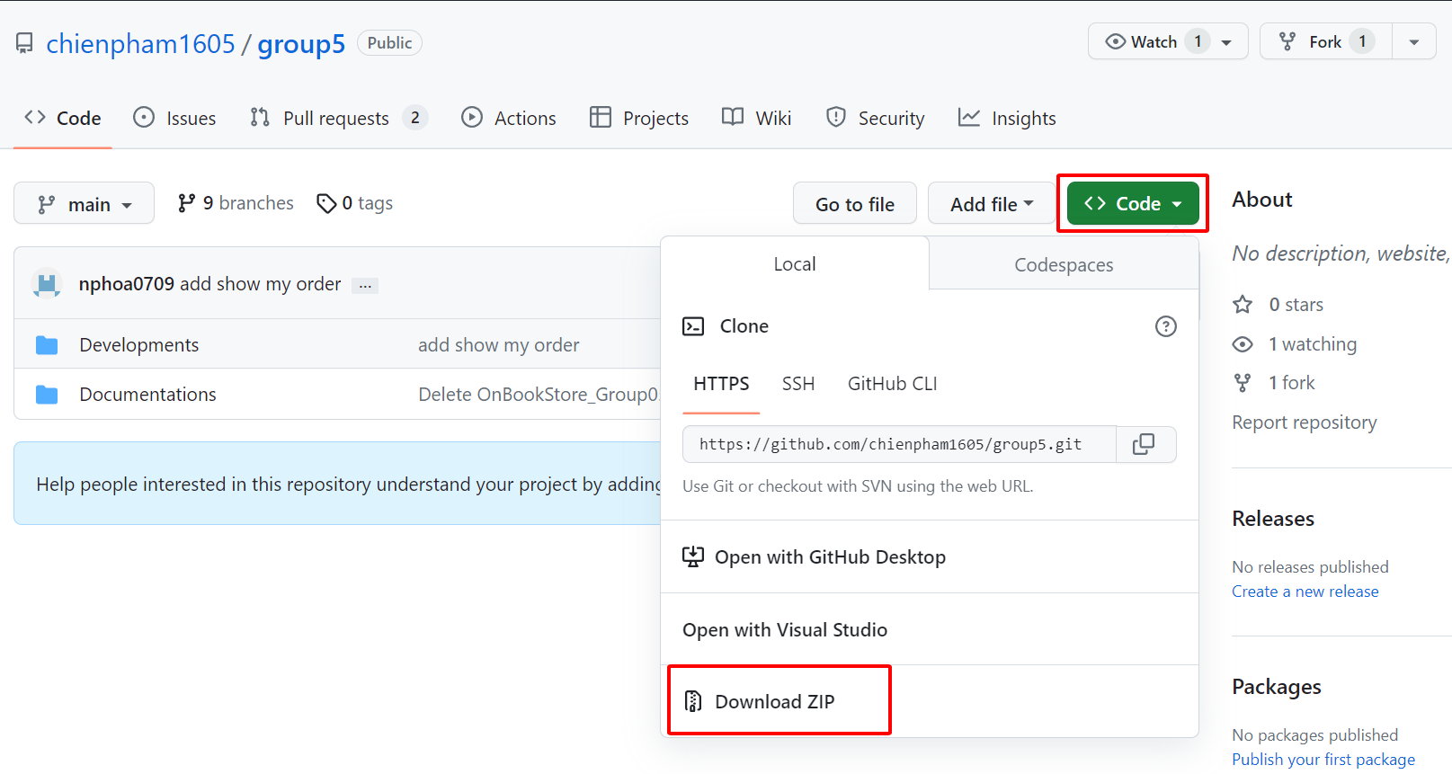
Figure 1
- Extract the file zip into the htdocs of xampp file
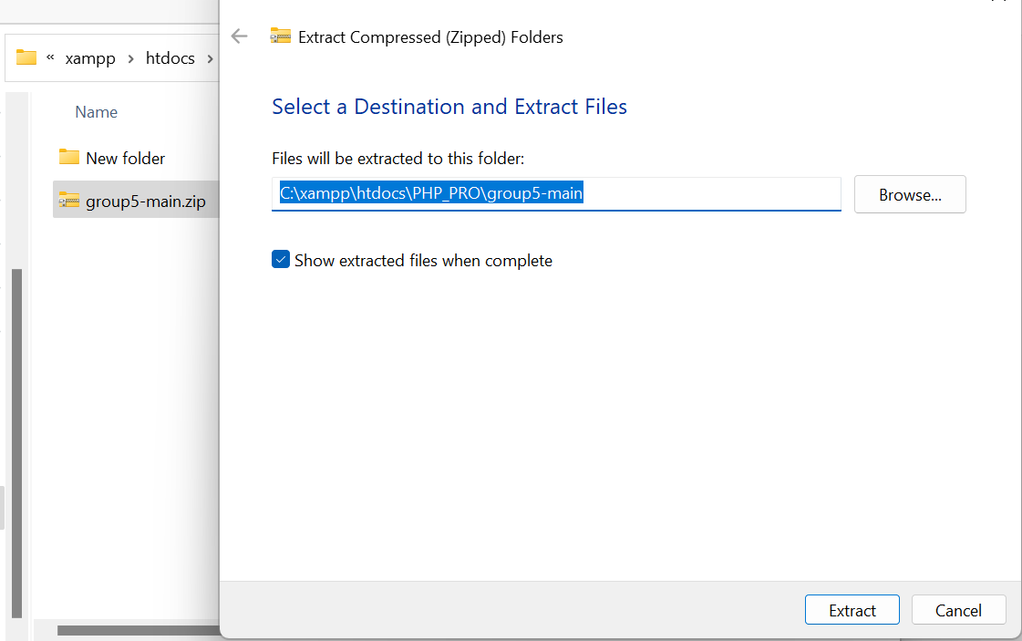
Figure 2

Step 2. Setup Database
- In XAMPP Control Panel, click start button Apache and MySQL
- Click Admin button to open MySQL.
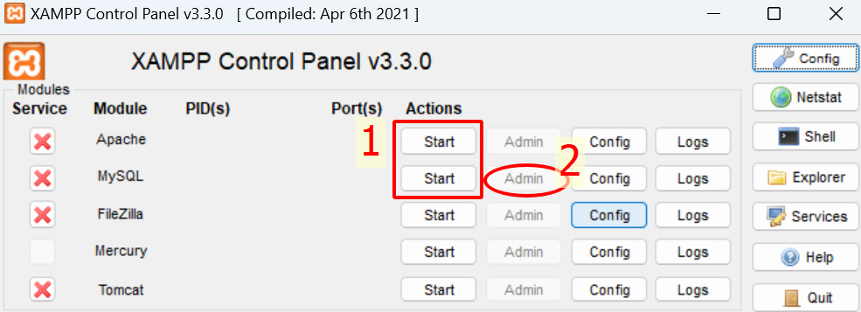
Figure 3
2.1. Create database OnBookStore_BD in phpMyAdmin with syntax as the figure H4
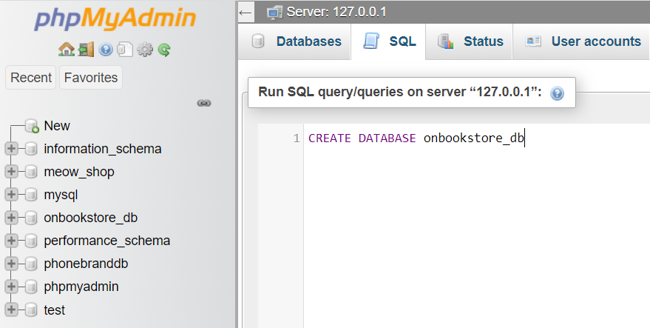
Figure 4
- Press Alt + Enter to commit database creating.

2.2. Import data to OnBookStore_BD as the figure H5
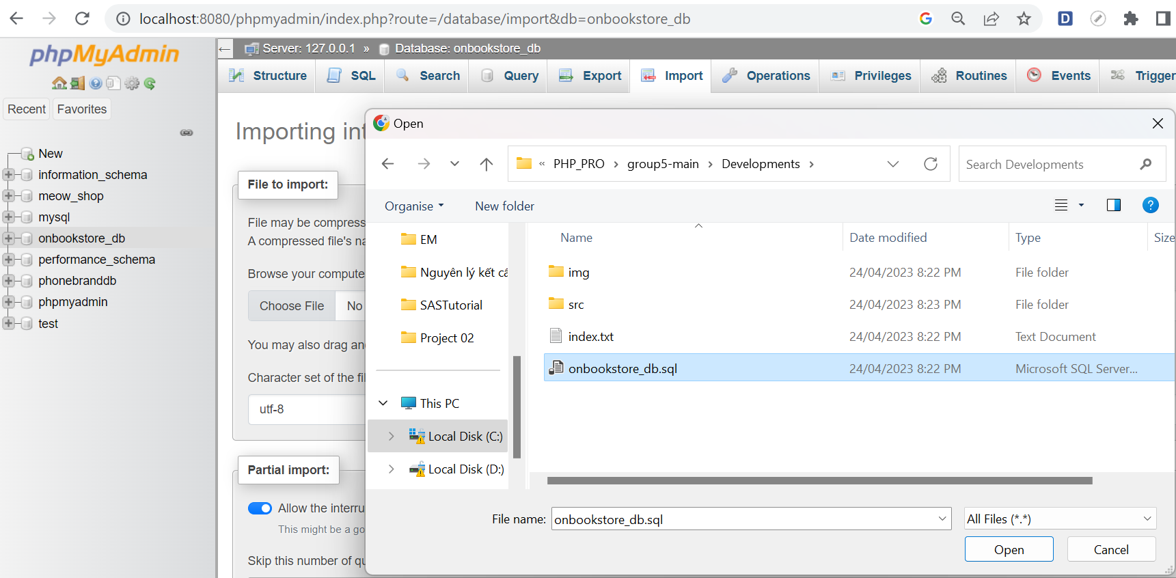
Figure 5
- In phpMyAdmin, choose the file onbookstore_db.sql,
- Click Import toolbar, choose Browser… button,
- Select onbookstore_db.sql in database Folder/ click Open.
- Click Import button at the end of the screen to finish.

Step 3. Open URL.
- Open page of admin: Microsoft Edge:

http://localhost:8080/project/group5/group5/Developments/src/admin/modules/home/main.php
- Open page of user: Chrome.

http://localhost:8080/project/group5/group5/Developments/src/user/modules/home/main.php

C. Successful test
- The website is loaded successfully.
- Homepage should be displayed as described in the documentation like 2 figures below
User:



Webmaster:
